Design The Ideal Job

Brought to you by:

By Shelley Holmes
Copyright Shelley Holmes 2019

This ebook is licensed for your personal use only. It may not be re-sold or given away to other people. If you would like to share this book with others, please purchase an additional copy for each reader. If you’re reading this book and did not purchase it, or it was not purchased for your use only, then please purchase your own copy.
Thank you for respecting the hard work of the author.

This Ideal Job worksheet helps you identify exactly what will enable you to be at your best, both in your current role and in your next career position.
All too often people find themselves trapped in jobs they don't want.

If you take the time to use this Ideal Job worksheet, it will enable you to get clarity around the types of task, activities and environments, you need to be at your best.
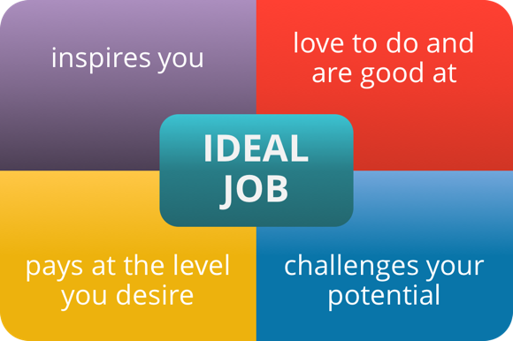
With this clarity, you can then have a discussion with your leader about your current role (or your next career move). What changes you’d like to make so that you can work to your strengths.
When you are working to your strengths, you will find that you are more free-flowing, more productive, happier and ultimately feel that you are doing exactly what it is you are 'meant' to do.
You can also use this Ideal Job activity sheet with your team members.
If you have noticed that the morale in the workplace has been a bit low, getting your team members to complete the exercise may be one of the first steps you can take to getting people back on track.

Design The Ideal Job
Brainstorm each of the quadrants below. Then, over the next few weeks, as you go about your daily work, keep adding items to the list.
Tasks/Activities I Love To Do, and Do Well (Q1) | Tasks/Activities I Love To Do, And Don’t Do Well (Q2)
Tasks/Activities I Do Well, That I Dislike (Q3) | Tasks/Activities I Don’t Do Well, and I Dislike (Q4)

Re-designing Your Current Role
1. Are there any tasks listed in Q1 that are not in your current role? If so, how can you re-design your current role to include those tasks/activities? Or, is there another job that you may be better suited to?
2. For the tasks in Q2, how can you up-skill yourself to get better at these tasks/activities?
3. For Q3 & Q4, how can you have these tasks/activities eliminated from your current role? Who in your team loves to do these types of tasks/activities? Can you train them to take over these items from you? What in their job will suffer by taking on an additional workload?
4. If the tasks in Q3 & Q4 can’t be taken out of your current role, how could you change your attitude toward them?

Identifying Your Best Environment

Make a list of your top 7 “non-negotiables”
Seven things that must be in my Ideal Job (Tasks, Environment, People) | Seven things that must NOT be in my Ideal Job (Tasks, Environment, People)
1 | 1
2 | 2
3 | 3
4 | 4
5 | 5
6 | 6
7 | 7

My Vision For My Perfect Work Day Is: (Write this out as if you were living a specific day one year from now. Describe in detail, what you can see, hear, feel, the type of people you will be interacting with, your surroundings, how you are behaving etc)

Supporting Resources:
This Ideal Job Exercise is a quick and easy activity. If you want to go into great depth, please access these resources:
Insights to Success With this program, you’ll get your own personal 50+ page report which reveals your behavioral style, your motivators and your emotional intelligence. Having this information at your fingertips means you’ll know exactly how to design your career to meet your needs.
Mindset of a High-Performance Employee This program guides you to the mindset that will have you seen as a rockstar in your organization! By the end of the program you’ll have a plan to guide your life and drive your professional success.
Starting Your Ideal Leadership Role With A Bang Whether you’re looking forward to a promotion or a new role – the tips and tactics in this program will enable you to make a great impression even before Day 1.

About Shelley Holmes

Shelley inspires leaders to be inspiring. Using tools, tips, ideas and strategies that help them to be really clear about what is ‘success critical’ and how to get there fast, Shelley guides leaders to flourish as they live, love and lead at a remarkable level .… making the dent in the universe they are destined to.
For several years, Shelley was a key leader in a High-Performance Organization (that had national and international recognition). It is this real-world experience that underpins and brings to life the theory and insights gained, from her deep study of high performance leadership.
Around the globe, she has worked with organizations (with total revenues in excess of $116 billion) and supports thousands of individual leaders through, coaching, consulting, workshops, webinars, audio programs and the Make A Dent Leadership website (which has over 5,000 visitors per day).

Shelley’s Philosophy...
Whether you like it or not how you show up at work defines you as a human being.
On grand and small scales, the way you interact with others, the products and services you are a part of delivering, all roll together to become a part of the legacy that you leave behind. The way you deal with others, the things you teach them, that cause them to grow, and become a better version of themselves .... as individuals, work colleagues, leaders, and parents ... now that defines who you are!
If you are ready to be the best possible version of yourself, to lead with more energy and passion than you thought possible... if you are ready to make a dent in the universe ... then:
There are hundreds of resources like this at Make A Dent Leadership where you can join our community of leaders who are focusing on being inspired and inspiring and making their dent in the universe.

You can connect with Shelley

Website: MakeADentLeadership.com
Contact: Email
Twitter: twitter.com/MakeADentLeader
Facebook: facebook.com/MakeADentLeadership
LinkedIn: linkedin.com/in/shelleyholmes

